**DOCUMENT OBJECT MODEL (DOM)**

* DOM is basically heart of any kind of web page manipulation.
* DOM is actually created by browser when any HTML document load inside it.
* Now basically we want to interact with HTML document from our JavaScript code to either add, change or remove content.
* Once the document is loaded in the browser, browser create an object which models this document this object is called **document object**.
* This object contain various properties and methods to interact with the HTML document. Whenever we want to do something like remove an element from browser or respond to user click on a button or add something to the browser, we do via document object.
* When we start coding in JavaScript, we have the access to this document object. We can use it to interact with the HTML pages using those different properties and methods.
* DOM also describe how a document looks in a visual way too and having an understanding about that will help us a lot when it comes to interact with that.
* DOM describes our HTML page as a hierarchal tree of nodes.
* Where html tag is behaves like root node. Everything else is inside it. Inside the html we have head and body tag.
* Inside head we have title tag, and then text node.
* Inside body we have h1 tag, div tag.
* Inside div tag, we have paragraph tag.
* Inside these paragraph, we have text which is called text node and all node other than text node is called element node.
* So, the idea is whenever we want to interact with the webpage. We use DOM to get access to this document object and we get a reference to a particular node for example this **h1** tag, we can use some different methods and properties to change its content and change its style or remove it or do something else with it.

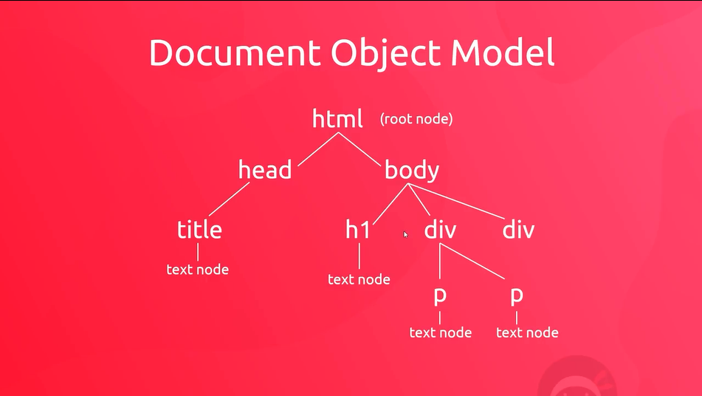.

Now practical part how we actually access this document object and how we get a reference to an element.

* This process of reaching in and selecting element is known as **querying the DOM**.